DE**R ZENGİN
Pianist

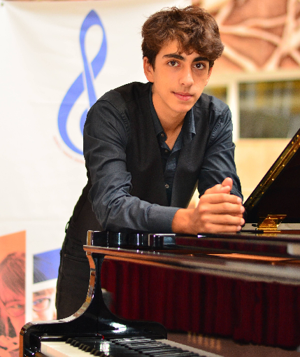

CONTACT
+90 506 **53 06

**d**zng@gmail.com

@d**mir_zng

HOBBIES
- Scuba Diving
- Motorbike Riding
- Cartoon Drawing

NEWS
- https://denizlihaberajansi.com/ha ber/1530/turkiye-nin-genc- yetenegi-denizli-odtu-den/

- https://meneksetokyay.com/2021
/10/10/genc-piyanist-demir- zengin/

- https://www.instagram.com/p/CS fgO4Njt6V/

EDUCATION
Denizli Hakkı Derekoylu Fine Arts School
2017 -

ODTU Gelistirme Vakfi Okullari
2011-2017

TEACHERS STUDIED WITH
  - I started playing the piano with Eylem Karademir at the first year of high school at the age of 13

  - In 2019 I started private piano lessons with Ellada Nadjafova
whom I’m still studying with after school.

  - In August 2020 I attended 18th International Gumusluk Classic Music Festival Piano Masterclasses with
    - State Artist Gulsin Onay,
    - Valerian Shiukashvili from Georgia
    - Prof. Pablo Galdo from Italy.

  - In September 2020 I started Bilkent University Music and Arts Faculty half-time Music Education. I go to Ankara at the weekends to attend the classes where I take chorus and solmization lessons and study piano one-to-one with Gülnara Bahsis

  - In November 2021, I went to Northern Cyprus for a week to take private lessons from Rauf Kasimov.

AWARDS
1- International Young Talents Contest Istanbul. 2017- 2nd prize 2- International Music e-Contest 2020 - Gold Award
3- European Association of Folklore Festivals - ICH Partner of UNESCO
- International Music Fantasy Competition Russia- 2020 -Gold Medal 4- Sopravista International Online Festival- Contest "All Colours of Art" Italy 2020 - Laurate 1st degree
- KING'S PEAK International Music Competition – 2nd Place
- European Academic Artists Association- VI. ODIN International Music Online Competition 2020 - Honorable Mention
- Orbetello- Italy Junior Piano Competition 2021 - Honour Mention 8- 1st International ARTEPIANO e-Competition 2020 – Diploma
9- Rossall International Piano Competition 2021-Diploma

