LANGUAGE SKILLS
MOTHER TONGUE(S): Turkish

OTHER LANGUAGE(S):
English

Hir**ur Ayb**e

Listening
B2

Reading
B2

Spoken production B2
Spoken interaction B2

Writing
B2

Altunbaş
Date of birth: 17/05/20**
Gender: Female

CONTACT
Denizli, Turkey **hir**ybike@gmail.com

EDUCATION AND TRAINING
2018 – CURRENT – Denizli, Turkey

High school education
Hakkı Dereköylü Güzel Sanatlar Lisesi

HOBBIES AND INTERESTS
I like writing and painting as hobbies.

CREATIVE WORKS
09/2018 – 03/2019
Theatre Club
I learned about basic acting skills, the history of theatre.

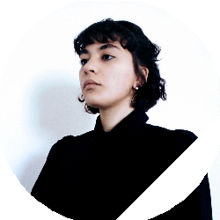

PUBLICATIONS

Stories and poems
I have sent multiple stories and poems to diﬀerent literature magazines and competitions, but any of them has published yet.

